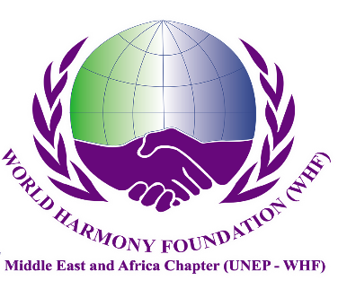
World Harmony Foundation Middle East and Africa Chapter
YOUTH COMMITTEE
World Harmony Foundation Middle East and Africa Chapter (WHF-MEAC) is a nonprofit organization and all our engagements are for humanitarian purposes, registered to United Nations Environment Programme World Harmony Foundation, certified No.679. WHF- MEAC is formed by ambitious figures of different ethnicities and from different UN regions who love peace and environmental protection. The mission of World Harmony Foundation is to promote harmony between human beings and mother nature, human beings and society and between nations.

WHF-MEAC is hiring youth volunteers worldwide. To bring human health and happiness back to their own harmony, your valuable contributions are indispensable. With all your talent, we can better promote harmony between human beings and mother nature, between human beings, between human beings and society, between nations, between religions, between families, and harmony and care of human bodies.

At WHFMEAFR YOUTH COMMITTEE, you will have the opportunity to understand the inter-governmental organization operation and International Etiquette without diplomatic relations restriction. Meanwhile, you can understand the most important issues worldwide, of have fun developing new skills, building friendships, and creating memories, and will engage in a wide variety of classes and opportunities.

At WHFMEAFR YOUTH COMMITTEE, You will build up the core competency as follows,
1) Policy planning and administrative capacity.
2) Communication coordination and leadership skills.
3) Analytical judgment and decision-making ability.
4) Learning and research ability.

Activities Photos

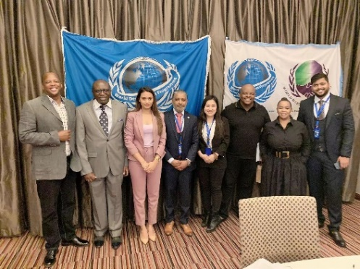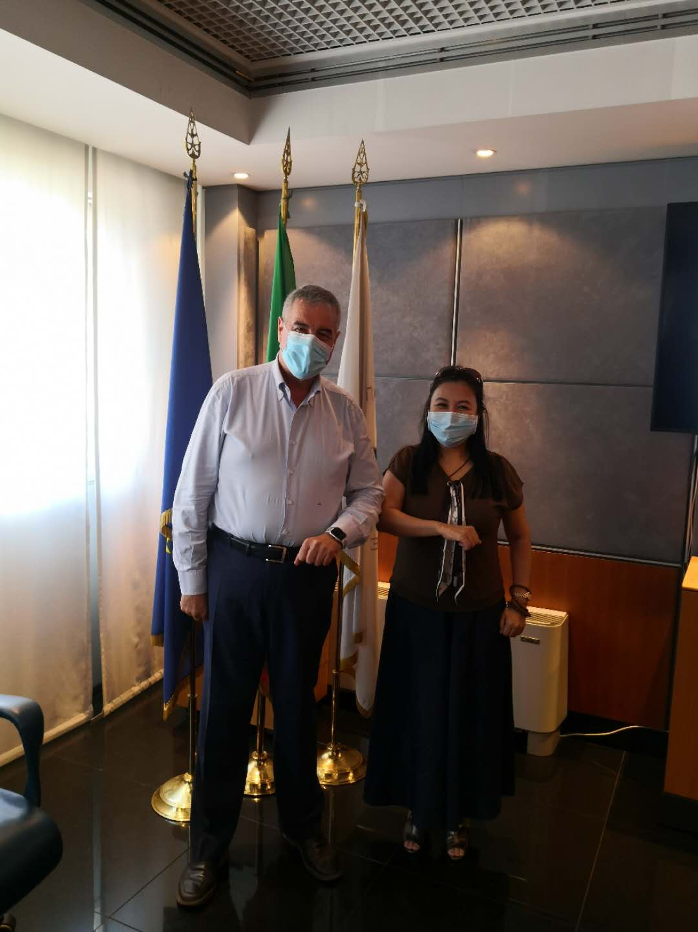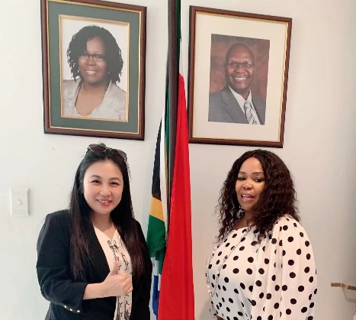
President: Huang, Tzu-Yun (aka Ariel Huang) & New Business Director: Ms. Ntombi Msiza

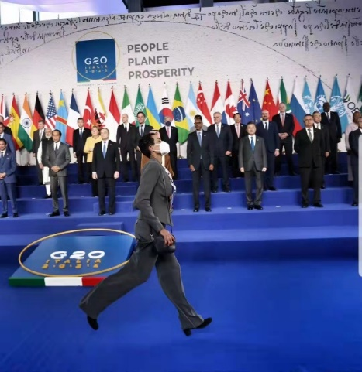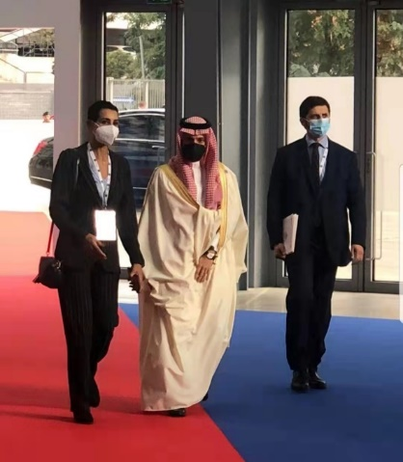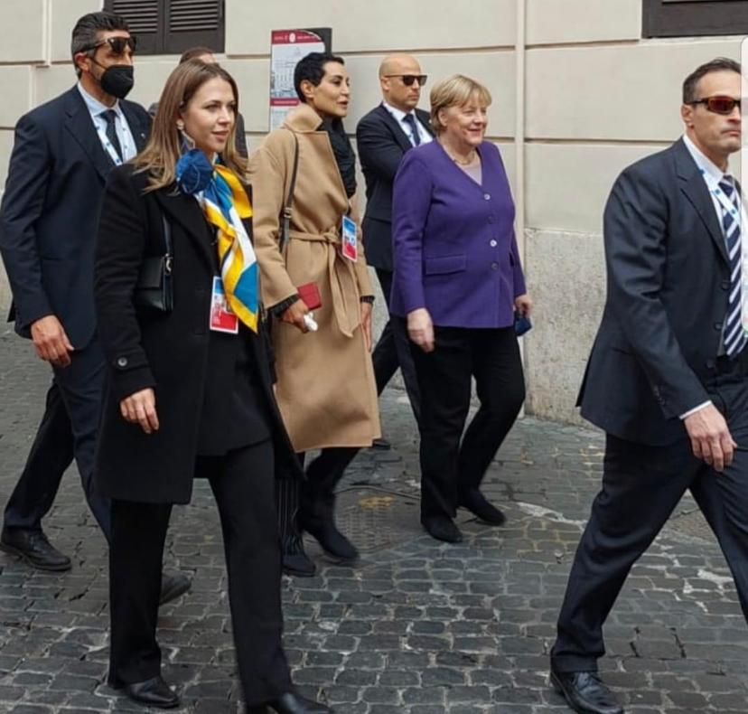
Secretary General of WHF-MEAC: Ms. Nadia Khdaidi, Organized for G20 Italia

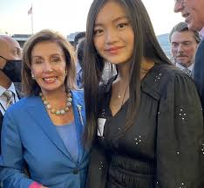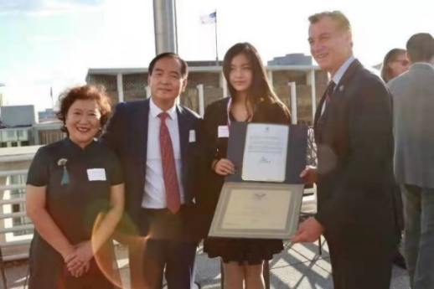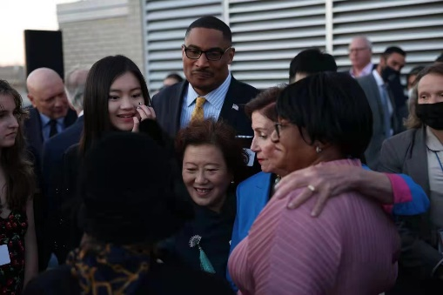
WHF Youth Leader ( Youth Committee Director) in 2021, Ms. Joseph Liu

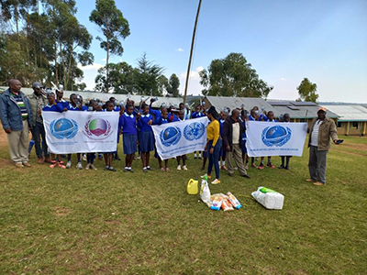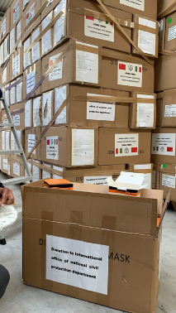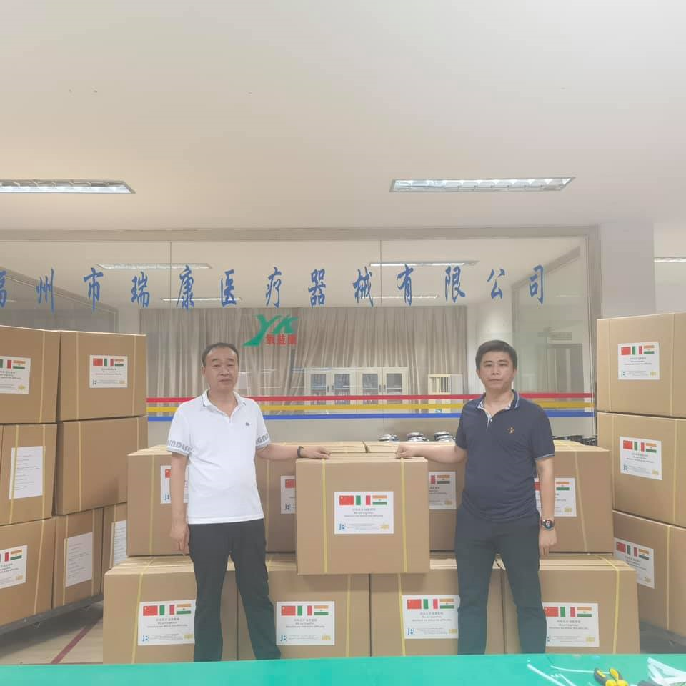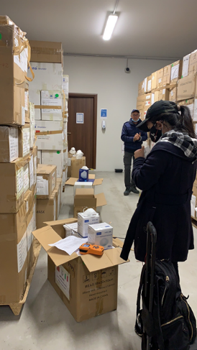
Public Benefit Activities

WHFMEAFR YOUTH COMMITTEE set up Clerical Department, Organization Department, Publicity Department, International liaison Department, Event Planning Department at present. The youth commissioners will be allocated to compatible department based on their talent and will hold a concurrent post as needed.

The main goals of each department at present are as following:
Clerical Department | - Assisting the WHF Committee in leading the organization and coordination of the daily government affairs work of the organs.  - Taking charge of conferences affairs of the committee  - Responsible for sending and receiving, batching, reviewing, printing, and distributing documents, telegrams, and materials of the whole committee.  - Responsible for the management, utilization, guidance, supervision and inspection of documents and files of the committee.  - To undertake other matters assigned by the leaders of the committee.
Organization Department | Organization Development  Mainly responsible for guiding, organizing, and managing the committee organization construction, committee member education management, committee member development, committee fee management, committee work system, and committee life system, and giving opinions and suggestions.  Cadre Development  Mainly responsible for the macro management of the leadership team and cadre team building, including planning, research and guidance on management system, policies and regulations.  Cadre education and training  Mainly responsible for the overall planning, macro-guidance, coordination services, supervision and inspection, system standardization of the national cadre education and training work, guiding the grading and classification of cadre education and training and international cooperation and exchanges of cadre education and training.
Publicity Department | - Responsible for guiding the research, study, and publicity of WHFMEAR worldwide.  - Responsible for guiding public opinion, guiding, and coordinating the news media of the central government to do a good job in news publicity.  - Managing media production administrative affairs, guiding and supervising media production, distribution, and screening work, organizing the review of media production.
International liaison Department | Responsible for unified management and coordination of international liaison work of committee; to organize and coordinate international work; organize committee representatives to participate in the international affairs and multilateral international meetings.
Event Planning Department | Responsible for planning and dealing related affairs of the sub-unit event of main objectives of WHFMEAFR： Environmental protection，Agricultural education，Empowering economic，Clean water and sanitation，Empowering education，Empowering women.

Enrollment position

WHFMEAFR YOUTH COMMITTEE | Registration fees (USD)
Youth Committee Elite | $5,000
Youth Committee Leader | $10,000
Youth Committee Directors (Only 3 seats per Country) | $30,000

These funds will serve for the following purpose in Africa:
MOBILE CLINICS | PHARMACEUTICALS | COMMUNITY HEALTH | TECHNOLOGY
Provide fully equipped mobile clinics in rural communities in Africa | Access to medicine and medical supplies for mobile & rural health clinics. | Improve Community Health Services and district clinics. | Digital technology to enhance diagnostic testing and tele-medicine.

Payment Options:

• Payments can be made online by PayPal at www whfmeafr.org/payment, additional surcharge
rate of 6% required, you can email info@ whfmeafr.org for your information.

• Bank Wire Transfer to the following account:
ACCOUNT NUMBER | 898130571174
BENEFICIARY NAME | WORLD HARMONY FOUNDATION MIDDLE EAST AND AFRICA CHAPTER LLC
BANK NAME | BANK OF AMERICA
Branch NAME | The Falls ( Branch Code: 075)
BANK ADDRESS | Bank of America, NA, 222 Broadway, New York, NY 10038, USA
SWIFT CODE | BOFAUS3N

• Authorized Taiwan Bank account: Please require by email to admin@whfmeafr.org

Outstanding Youth Award

Badge and Medal
Name | Rank | Award criteria
WHFMEAFR Honorary Title Medal |  | Outstanding people who have made significant contributions and enjoyed high reputations in promoting harmony between human beings and mother nature, between human beings, between human beings and society, between nations, between religions, between families, and harmony and care of human bodies
Outstanding Member Medal |  | Outstanding people who are consistent with vision of WHFMEAFR, excellent work style, high prestige, excellent work ability, outstanding achievements.
Hero Medal |  | In event, training or other work, outstanding people who have made outstanding achievements, made special contributions, and had a major influence and promotion role in the Africa and harmony.
Merit Medal | first class merit | Personnel who have made outstanding achievements in event operations, training, duty, scientific research, etc., who have made outstanding achievements and have made major contributions may be awarded first-class merits.
 | Second class merit | Personnel who have made outstanding achievements in event operations, training, duty, scientific research, etc., who have made outstanding achievements and have made major contributions may be awarded second-class merits.
 | Third class merit | Personnel who have made outstanding achievements in event operations, training, duty, scientific research, etc., who have made outstanding achievements and have made major contributions may be awarded third-class merits.
Diligence Commemorative Medal | Golden | Personnel who have served more than 2 or 3 times to the prescribed workhours.
 | Silver | Personnel who have served more than 1 times the above prescribed time.
 | Copper | Those who have cumulatively served in active service for one year but less than two years.

Questionnaire for parent 父母問卷

Native language input is allowed: 可使用非英文系母語回答
What do you expect your children gain in this experience?
你期望你的孩子從這次經歷中獲得什麼？
□Connections  人脈關係 | □Knowledge  知識 | □Recommendation letters 推薦函 |  | □Testimonial  資質證明 | □ International Worldview世界觀
How do you do when conflicts happen in front of children? How do you deal with family conflicts?
如何在孩子面前處理家庭內部衝突? 您通常如何處理家庭衝突?
Answer:

Please have a brief description of your children, what do you think their merits are and what needs to be improved.
請簡要描述一下您的孩子，您認為他們的優點是什麼以及需要改進的地方。
Answer:

Parent’s Signature家長簽名處:

The Attitudinal Assessment (Children)

The assessment should be viewed not only as an assessment of WHFMEAFR, but also as a gauge of attitude, outlook, and perspective. For each question, rate yourself on a scale of 1 to 4. In the first part of each question, the assessment of where the volunteer stands right now, the most motivated and driven volunteer would likely have at least seven ratings of a 4 and not a single rating below a 3. Volunteer with three or more questions for which the answer was a 1 will need extra assistance to develop proper goals and may require frequent rewards, discussion, and education.

- What would you consider your present attitude toward being volunteer in WHFMEAR?

1 - I can’t stand the thought of it.
2 - I’ll do it because I know I should, but I don’t enjoy it.
3 - I don’t mind to be volunteer, and I know it is beneficial.
4 - I am motivated to bring human health and happiness back to their own harmony.

*Your answer: _____

Describe how those feelings of being volunteer in WHFMEAFR might bring about positive change in your life:

- What would you consider your present attitude toward goal achievement?

1 - I feel that whatever happens, happens, and I’ll roll with the punches.
2 - I set goals and believe it adds clarity and gives me some control over my outcome.
3 - I write down my goals and believe it is a very valuable exercise in determining my future performance and achievement.
4 - I have written goals and I review them often. I believe I have the power to achieve anything I desire and know that setting goals is a vital part of achievement

*Your answer: _____

How would you like to feel about goal achievement, if you could change your feelings?

*Your answer: _____

Describe why and any specifics of how you would like to change your feelings about goal achievement and how those feelings might bring about positive change in your life:

- How important to you are the concepts of health and well-being?

1 - I don’t need to put any effort into bettering my health.
2 - I make certain I devote some time and effort into bettering health and well-being.
3 - I am committed to maintaining and working to improve health and well-being.
4 - Health and well-being are the foundation of all that I achieve, and they must remain my top priorities.

*Your answer: _____

How would you like to feel about the concepts of health and well-being, if you could change your feelings?

*Your answer: _____

Describe why and any specifics of how you would like to change your feelings about the concepts of health and well-being and how those feelings might bring about positive change in people’s life:

- How strong and driving is your desire for improvement?

1 - I’m really pretty satisfied with the way things are. Striving for improvement might leave me frustrated and disappointed.
2 - I’d like to improve but don’t know that it’s worth all the work involved.
3 - I love feeling as if I’ve bettered myself and am open to any suggestions for improvement.
4 - I’m driven to excel and am committed to striving for consistent and ongoing improvement.

*Your answer: _____

How strong and driven would you like to feel about improvement?

*Your answer: _____

Describe why and any specifics of how you would like to change your feelings about improvement and how those feelings might bring about positive change in your life

- How do you feel about yourself and your abilities (self-esteem)?

1 - I am not comfortable with the way I look, feel, or perform in most situations.
2 - I would love to change many things about myself although I am proud of who I am.
3 - I’m very good at the things I must do, take pride in many of my achievements, and am quite able to handle myself in most situations.
4 - I have great strength, ability, and pride.

*Your answer: _____

How would you like to feel about yourself and your abilities, if you could change your feelings?

Your answer: _____

Describe the biggest setback and how did you deal with it

Your answer: _____

Describe why and any specifics of how you would like to change your feelings about yourself and your abilities and how those feelings might bring about positive change in your life:

- How do you feel about present Africa conditions in terms of the way you look?

1 - I would like to completely endeavor to ameliorate Africa conditions.
2 - There are many things about Africa conditions that I’m not comfortable with.
3 - For the most part it looks OK, but I do feel uncomfortable with a few things about Africa condition.
4 - I am proud of present Africa conditions.

*Your answer: _____

Describe why and any specifics of how you would like to change your feelings about the way present Africa look and how those feelings might bring about positive change in your life:

- How strongly do you believe that you can improve Africa?

1 - I believe most of conditions are genetic, and most efforts to change would be a waste of time.
2 - I’ve seen many people contribute to Africa for the better and am sure with enough effort I can see some improvement.
3 - I strongly believe the WHFMEAFR can bring about some improvement.
4 - I know without question that with WHFMEAFR I can bring about dramatic changes in Africa

*Your answer: _____

How would you like to feel about your ability to improve Africa, if you could change your feelings?

*Your answer: _____

Describe why and any specifics of how you would like to change your feelings about your ability to improve Africa and how those feelings might bring about positive change in your life:

- When you begin a program or set a goal, how likely are you to follow through to its fruition?

1 - I’ve never been real good at following things through to the end.

2 - With the right motivation and some evidence of results I think I might stick to a program.

3 - I have the patience and ability to commit to a program and will give it a chance in order to assess it value.

4 - Once the goal is, there’s no stopping me

*Your answer: _____

How would you like to feel about following through on goals, if you could change your feelings?

*Your answer: _____

Describe why and any specifics of how you would like to change your feelings about following through on goals and how those feelings might bring about positive change in your life:

APPLICATION FORM
PERSONAL DOSSIER
1
Parent (Guardian) Information
Please answer each question clearly and completely. TYPE OR PRINT LEGIBLY.  Read carefully and follow all directions. |  |  |  |  | Photos
Guardian:監護人 | □ Parents 父母 | □ Father only  父親 | □ Mother only  母親
□ Other 其他
Relative Title: 親屬稱謂
Guardian information監護人資訊
1. Family name 姓氏 | First name 名字 | Middle name 中間名 | Maiden name, if any 婚前姓氏
2. Date of Birth 生日(day/month/yr.) | 3. Nationality 國籍 | 4. Marital Status: 婚姻狀況 | 5. Sex (M / F) 性別
6. Height 身高 | 7. Weight 體重 | 8. Family Genetic Disease: 家族遺傳疾病
9. Address 住家地址 |  |  | 10. Mobile No.:手機號
11. Social Media Information 社交媒體 | □ Line □ Whatsapp :  □ Wechat □ Other s  □ Email :
12.Highest Academic Degree Obtained 最高學歷
13. Company Name 公司名稱 |  | 14. Seniority:  年資 | 15. Current Position  目前職位
16. Company address 公司地址
17. Have you ever had oversea study or working experience? 你有没有海外学习或工作经验？
If answer is “yes”, Where? 如果有,請說明地方

18. ARE YOU NOW OR HAVE YOU EVER BEEN A CIVIL SERVANT AS GOVERNMENT EMPLOYEE?
您现在是还是曾经作为政府雇员担任公务员？
If answer is “yes”, WHEN?如果答案是“是”，什么时候？

19. HAS ANY OF YOUR RELATIVES NOW OR HAVE THEY EVER BEEN A CIVIL SERVANT AS GOVERNMENT EMPLOYEE?
你现在有没有亲戚，或者他们曾经是公务员，作为政府雇员？
If answer is “yes”, please describe? 如果回答“是”， 请描述一下？

Child Information
1. Family name 姓氏 | First name 名字 | Middle name 中間名 | Maiden name, if any 婚前姓氏
2. Date of Birth 生日(day/month/yr.) | 3. Nationality 國籍 | 4. Marital Status: 婚姻狀況 | 5. Sex (M / F) 性別
6. Height 身高 | 7. Weight 體重 | 8. Family Genetic Disease: 家族遺傳疾病
9. Address 住家地址 |  |  | 10. Mobile No.:手機號
11. Social Media Information 社交媒體 | □ Line □ Whatsapp :  □ Wechat □ Other s  □ Email :
12.Highest Academic Degree Obtained 最高學歷
13. Have you ever had oversea study or working experience? 你有没有海外学习或工作经验？
If answer is “yes”, Where? 如果有,請說明地方

14. Entry into WHF-MEAC Youth Committee might require assignment to any area of the Africa in which the WHF-MEAC
might have responsibilities.
- Are there any limitations on your ability to perform in your prospective field of work?
- Are there any limitations on your ability to engage in all travel?

15. Knowledge of languages.
(1) Language Name | READ  □ Easily □ Not Easily | WRITE  □ Easily □ Not Easily | SPEAK  □ Easily □ Not Easily | UNDERSTAND  □ Easily □ Not Easily
(2) Language Name | READ  □ Easily □ Not Easily | WRITE  □ Easily □ Not Easily | SPEAK  □ Easily □ Not Easily | UNDERSTAND  □ Easily □ Not Easily
(3) Language Name | READ  □ Easily □ Not Easily | WRITE  □ Easily □ Not Easily | SPEAK  □ Easily □ Not Easily | UNDERSTAND  □ Easily □ Not Easily
(4) Language Name | READ  □ Easily □ Not Easily | WRITE  □ Easily □ Not Easily | SPEAK  □ Easily □ Not Easily | UNDERSTAND  □ Easily □ Not Easily
16.Special Statement | Special diet habit：□None □Vegetarian □Other: ________
 | Medication: □None □Yes: _____________
 | Health status: □Healthy □Asthma □Heart Disease □Other: ________
 | If any, please detail special health conditions that need to be noted: ______________
17. HAVE YOU EVER BEEN ARRESTED, INDICTED, OR SUMMONED INTO COURT AS A DEFENDANT IN A CRIMINAL PROCEEDING, OR CONVICTED, FINED OR IMPRISONED FOR THE VIOLATION OF ANY LAW (excluding minor traffic violations)? YES NO
If “yes”, give full particulars of this case in an attached statement.

18. I certify that the statements made by me in answer the foregoing questions are true, complete and correct to the best of my knowledge and belief. I understand that any misrepresentation or material omission made on a Personal Dossier form or other document requested by the organization renders a staff member of the Executive Council member liable to termination or dismissal from all diplomatic duties and formal assignments.

SIGNATURE:
N.B. You will be requested to supply documentary evidence, which would support all statements you have made above. Please do not, send further documentary evidence unless requested by us and, in any event, do not submit the original texts of references or testimonials unless they have been obtained for the sole use of WHF-MEAC organization as corporate responsible support.

